220CT – Data and Information Retrieval
Coursework
VENELIN DANIELOV DIMITROV
ID No: 6297262
Task 1, Part 1: DB Design (15 marks)
The International Space Station (ISS) is a habitable artificial satellite in low Earth orbit. It is the ninth space station to be inhabited by crews following previous orbital stations that were launched by the US the former Soviet Union and later Russia. The ISS is intended to be a laboratory, observatory and factory in space as well as to provide transportation, maintenance, and act as a staging base for possible future missions to the Moon, Mars and beyond. In order to support the crew and overall operation of ISS the space agencies in charge of running the station conduct regular missions to launch spacecraft carrying payloads of essential or replacement equipment up to ISS. A payload inventory, see table below, is recorded of each mission, consisting of the space agency leading the mission and the equipment payload to be sent up to ISS. The overall weight of the payload is also determined in order to calculate the fuel needed for orbital insertion of the spacecraft to successfully rendezvous with ISS.
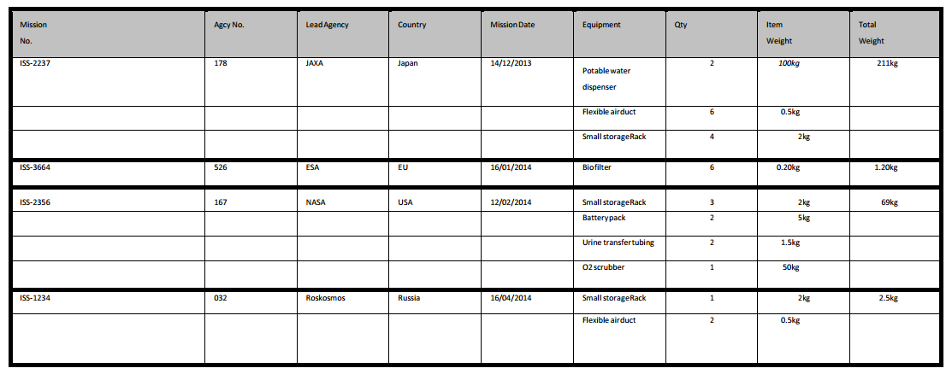
Deliverable: Using SQL, implement the database above. To do so, you’ll need to normalise the table (should that be required), identify the attributes, create and Entity-Relationship Diagram and create the tables using SQL commands.
SOLUTION:
For this graph I would use traditional relation database form because it’s a small dataset and can easily be split into separate tables using normalization.
1NF
The main table was not in the first form because “Equipment” had multiple values stored. So the solution to this one will be to create a new table called “Equipment” or “Inventory” with the only contents related to that specific item (Mission Number, Equipment, Quantity , Item Weight) gathered from the original example. And the other one containing the “Agency” and “Mission related information”.
Mission Number | Agency Number | Lead Agency | Country | Mission Date | Total Weight
ISS-2237 | 178 | JAXA | Japan | 14/12/2013 | 211kg
ISS-3664 | 526 | ESA | EU | 16/01/2014 | 1.20kg
ISS-2356 | 167 | NASA | USA | 12/02/2014 | 69kg
ISS-1234 | 032 | ROSKOSMOS | Russia | 16/04/2014 | 2.5kg

Mission Number | Equipment | QTY | Item Weight
ISS-2237 | Potable water dispenser | 2 | 100kg
ISS-2237 | Flexible air duct | 6 | 0.5kg
ISS-2237 | Small storage rack | 4 | 2kg
ISS-3364 | Bio filter | 6 | 0.20kg
ISS-2356 | Small storage rack | 3 | 2kg
ISS-2356 | Battery pack | 2 | 5kg
ISS-2356 | Urine transfer tubing | 2 | 1.5kg
ISS-2356 | O2 scrubber | 1 | 50kg
ISS-1234 | Small storage rack | 1 | 2kg
ISS-1234 | Flexible air duct | 2 | 0.5kg

2NF
If I want it to be able to transform it from first form (1NF) into second form (2NF), any of the attributes depending only a part of a single table have to be removed and put into a third new one. Therefore the new table will hold the contents of equipment and weight from the “Equipment” table from 1NF. The repeated elements will be erased.

Mission Number | Agency Number | Lead Agency | Country | Mission Date | Total Weight
ISS-2237 | 178 | JAXA | Japan | 14/12/2013 | 211kg
ISS-3664 | 526 | ESA | EU | 16/01/2014 | 1.20kg
ISS-2356 | 167 | NASA | USA | 12/02/2014 | 69kg
ISS-1234 | 032 | ROSKOSMOS | Russia | 16/04/2014 | 2.5kg

Mission Number | Equipment | QTY
ISS-2237 | Potable water dispenser | 2
ISS-2237 | Flexible air duct | 6
ISS-2237 | Small storage rack | 4
ISS-3364 | Bio filter | 6
ISS-2356 | Small storage rack | 3
ISS-2356 | Battery pack | 2
ISS-2356 | Urine transfer tubing | 2
ISS-2356 | O2 scrubber | 1
ISS-1234 | Small storage rack | 1
ISS-1234 | Flexible air duct | 2
Equipment | Item Weight
Potable water dispenser | 100kg
Flexible air duct | 0.5kg
Small storage rack | 2kg
Bio filter | 0.20kg
Battery pack | 5kg
Urine transfer tubing | 1.5kg
O2 scrubber | 50kg

3NF

In order to transform from 2NF to 3NF, we have to remove any attributes that are more dependent on other non-key attributes and place them in a new table. The new table will be called “Agency”. Looking after that at the table “Equipment” we see that I has no primary key because there are no unique attributes, so the next move will be to put two foreign keys to link the two tables – “Inventory” and “Missions”

Mission Number | Agency Number | Mission Date | Total Weight
ISS-2237 | 178 | 14/12/2013 | 211kg
ISS-3664 | 526 | 16/01/2014 | 1.20kg
ISS-2356 | 167 | 12/02/2014 | 69kg
ISS-1234 | 032 | 16/04/2014 | 2.5kg

Mission Number | Equipment | QTY
ISS-2237 | Potable water dispenser | 2
ISS-2237 | Flexible air duct | 6
ISS-2237 | Small storage rack | 4
ISS-3364 | Bio filter | 6
ISS-2356 | Small storage rack | 3
ISS-2356 | Battery pack | 2
ISS-2356 | Urine transfer tubing | 2
ISS-2356 | O2 scrubber | 1
ISS-1234 | Small storage rack | 1
ISS-1234 | Flexible air duct | 2
Agency Number | Lead Agency | Country
178 | JAXA | Japan
526 | ESA | EU
167 | NASA | USA
032 | ROSKOSMOS | Russia
Equipment | Item Weight
Potable water dispenser | 100kg
Flexible air duct | 0.5kg
Small storage rack | 2kg
Bio filter | 0.20kg
Battery pack | 5kg
Urine transfer tubing | 1.5kg
O2 scrubber | 50kg

E-R Diagram

